Latest Round-ups:
#26
Season 2019/20
Midweek Action: Bridgwater defeated Premier Division strugglers Wellington 2-0 in front of a healthy midweek crowd at Fairfax Park (pictured right). December signing Oscar Latas opened his account for Bridgwater when breaking the deadlock during the 16th minute, before Jack Taylor made sure of the victory 13 minutes from time.
Wells City completed a highly impressive 4-0 victory over Longwell Green Sports on Tuesday evening to move within a point of the First Division table-toppers. The home side made a dream start to the game, going ahead after just six minutes when Harvey Hadrill headed home thanks to an assist from the influential Craig Herrod. Tom Hill then converted a penalty midway through the first half to double the lead, before Hadrill made it 3-0 ten minutes later thanks to an excellent individual goal which saw him beat a couple of defenders before powering home. The second half was a quieter affair, but Wells still had time to add another goal to their tally, with Harry Foster firing home an 86th minute penalty after Hadrill had been felled in the box. There was also a dominant home win for Wincanton, with three different scorers helping them defeat Almondsbury 3-1. The hosts hadn’t played since late December, but they showed no signs of rust, going ahead after just 13 minutes through Louis Irwin. Toby Dolton Cole and Brett Cotterill then each scored at the beginning of the second half to extend the lead to three, with Greg Parr scoring a late consolation for the out-of-form Almondsbury. Wednesday night’s matches were also generally one-sided, with three of the league’s bottom five sides falling to defeats. Hengrove’s improved form around the turn of the year has since taken a dip, and they have now suffered back-to-back defeats after losing 3-0 at home to Portishead. A low driven effort from Callum Eastwood was followed soon after by a Kyle Egan goal to give the Posset a two-goal lead at the break, with Joe Cattermole then adding gloss to the scoreline when he struck in second half stoppage time. Bishops Lydeard also prevailed by a 3-0 scoreline, easing to victory over Bishop Sutton at Cothelstone Road. The home side flew out of the blocks, going ahead inside 30 seconds when Ryan Brereton managed to turn home a cross from Mark Clunie. Ben Hebditch then doubled Lydeard’s advantage midway through the first half, before the in-form Jake Quick struck again on the hour mark to take his tally to six goals from his previous five games. Lebeq rebounded well from their heavy defeat last weekend by beating Devizes Town 4-1 at Oaklands Park. Shah Bhakerd was the standout performer for Lebeq, scoring in either half, with Gareth Gallop and Elan Plummer also finding the back of the net during a much-improved outing for the home side.
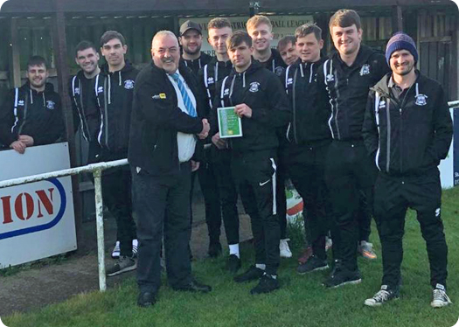
Jack Crago’s epic season in knockout competitions continued on Wednesday night, when he scored all of Tavistock’s goals in their 3-1 win over Clevedon in the Les Phillips Cup. Crago scored twice inside the opening 11 minutes to put Tavistock in control, before Jay Murray pulled a goal back for the visitors just before half time. Crago then completed his hat-trick from the penalty spot 17 minutes from time to book a home quarter-final with Warminster. 24 hours earlier, a pair of third round clashes in the Gloucestershire FA Challenge Trophy took place, with Bitton and Oldland Abbotonians both progressing. Two goals from Harrison Kyte in the final 20 minutes helped Bitton beat Tuffley Rovers 2-1, while a four-goal first-half blitz from Oldland saw them defeat Chipping Sodbury 4-0. Lucas Hart and Frank Taylor-Fox put Oldland two goals ahead, before a quick-fire brace from Josh Dempsey capped a dominant 45 minutes for the visitors.
Awards Update
Western League Director Colin Goodland presents Sherborne Town skipper George Mapletoft with the First Division Team of the Month award for December.

Premier Division: Three goals early in the second half helped table-toppers Bradford Town come through a potentially difficult clash away at Clevedon, eventually winning by four goals to one. The game started at a breakneck speed, and no sooner had Tyson Pollard’s deflected effort given Bradford a seventh minute lead, the hosts responded through Jay Murray to level the scores. Dean Griffiths’ header restored the Bobcats advantage at the beginning of the second half, with Charlie Maddison then scoring for the third consecutive fixture to make it 3-1. The fourth goal came just after the hour mark, with Matt Morris putting the result beyond doubt to maintain Bradford’s three-point lead over the chasing pack. Plymouth Parkway remain hot on the leaders tail, with a hat-trick from Mikey Williams firing them to a 3-0 win away at Chipping Sodbury Town. Williams struck twice in the first half, before completing his treble in the 66th minute to hand the Devon side a comfortable victory. Third-placed Exmouth were held to a goalless draw by Bridgwater, but the in-form Shepton Mallet found a way to come from behind to beat Roman Glass St George 4-1. Having fallen behind in the opening minutes, Shepton hit back just prior to the interval when Asa White rose highest to nod home Craig Loxton’s corner. With 15 minutes left on the clock, Jack Fillingham gave Shepton their first lead, finishing well after a mazy run saw him beat two defenders, before Aaron Seviour scored twice in the closing stages to complete the victory. Hallen left it late before taking all three points from their away clash with Keynsham. The visiting side made a dream start to the game, with star man Kyle Thomas firing home a fourth minute free-kick, only for the K’s to draw level through Jamie Noble. With the win up for grabs, Hallen pushed forward and captured their fifth win on the bounce thanks to a well-guided header from Aron Robbins two minutes from time.

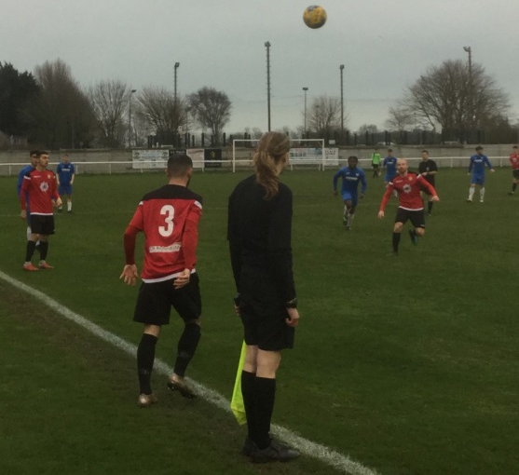
There was also late drama at Homers Heath, where a late penalty managed to salvage a 1-1 draw for Brislington away at Buckland. With Brislington already down to ten men, Buckland joined them early in the second half, but from the resulting spot kick, Ken Griffiths denied Neikell Plummer to ensure the game remained goalless. The home side took advantage of that miss when Lloyd Gardner put them ahead in the closing stages, but Brislington showed a tonne of resolve, with Plummer winning his side another penalty five minutes from time. This time, Simon Prangley took on Griffiths from 12 yards, and was more successful than his teammate, giving his side a share of the points. In the battle at the bottom, Tony Pinder’s fantastic hat-trick helped Bridport overturn a half time deficit to beat Odd Down 4-3. Pinder’s first goal midway through the first half cancelled out Anthony Conradi’s opener, only for Odd Down to retake the lead through Elliot Dugan. A terrific 11 minute spell midway through the second half sealed victory for Bridport, with Pinder scoring twice in quick succession to complete his hat-trick, before Lewis Clarke also turned the ball home to completely turn the game on its head. Odd Down have been on a dreadful run of form, but they gave themselves a chance of stealing something late on following a goal from Lewis Ellington, but it wasn’t to be and they remain rooted to bottom spot. Bitton fought back from a slow start, scoring in either half to beat Westbury United 2-1. After Ryan Bole’s 10th minute free kick had put the Wiltshire side in front, Scott Brice managed to draw the home side level when he finished from close range following a goalmouth scramble. The winning goal then came on the hour mark, with Karim Rendall providing the vital touch to give Bitton their 12th league win of the campaign. Having suffered three heavy defeats to start the year, Cadbury Heath will be thankful for home comforts, defeating Wellington 1-0 to grab a precious home victory. The solitary goal came after just four minutes, with Matt Binding’s looping header finding the back of the net, but Heath’s star man turned out to be keeper Ollie Jones who made a pair of blinding saves during the second half to preserve his clean sheet. Tavistock seem to be close to unbeatable at the moment, and they secured another three points on Saturday afternoon, beating Cribbs 3-0 at Langsford Park.
Action from Bridport’s 4-3 victory over Odd Down courtesy of John Pool.
First Division: Calne Town have taken over top spot after battling to a 1-0 win in the game of the day away at Wells City. The in-form duo met in Somerset, and much of the major action took place in the early stages, with Calne awarded an early penalty following a foul on Jamal Chevolleau inside the hosts area. Chevolleau dusted himself down before tucking away the resulting penalty, but Calne were soon on the back-foot after losing Matt Hudson to a 16th minute red card. The Lilywhites spent the remainder of the match trying to keep Wells at bay, and they managed to do so to pick up a memorable victory. In a game which followed a similar pattern, Longwell Green Sports suffered their second defeat on the spin after losing 1-0 at home to Cheddar. It was an early goal which also decided this game, with Ricky Bennett volleying home a stunner from all of 30 yards to give Cheddar their first victory since Boxing Day against the previous league leaders. A dominant second-half performance from Sherborne Town helped them claim a 4-0 win over struggling Bishop Sutton at Raleigh Grove. Following a goalless first half, Sam Farthing eased the home side’s nerves with a goal five minutes after the restart. Joe Smith then doubled the Zebra’s tally three minutes later before a late double from Anthony Herrin rounded out the victory.
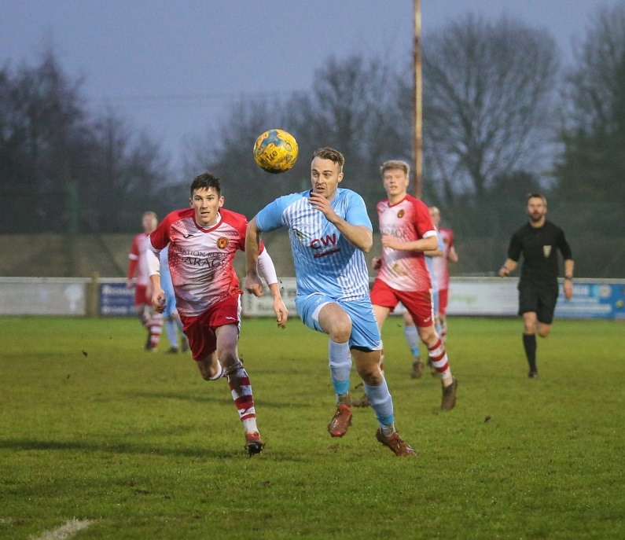
In one of the standout ties of the day, Corsham saw off Radstock by two goals to nil to leapfrog their opponents up into sixth spot. It proved to be another fixture where the second half proved to be decisive, with Corsham taking a 50th minute lead when Josh Bright burst through before curling the ball home. The visitors tried to respond, but before they could get back on level terms, Corsham managed to double their lead when Ash Alchin pirouetted his way past two defenders before slotting the ball into the back of the net. In the day’s early kickoff at Nursteed Road, Bishops Lydeard enjoyed another big win away from home, scoring three times during the first half on their way to a 4-1 victory over Devizes. After Jake Quick had put the visitors in front, Charlie Wilson then doubled their tally, before Quick teed up his brother Jason who headed home a third goal in the 44th minute. Devizes threatened a fightback, scoring early in the second half, but that never materialised and Lydeard ran out comfortable winners, with Zac Ryder adding a fourth goal five minutes from time. Hengrove were the biggest movers of the day, rising three spots to 14th following a 2-1 win away at Lebeq United. The Grove had two goalscoring defenders to thank for their victory, with Luke Crewe and then Shaun Trott finding the back of the net, with Trott’s 88th minute effort giving them a rare away victory. Almondsbury haven’t had the best of times recently, so they will have enjoyed beating bottom side Bristol Telephones 4-0 on Saturday afternoon. The Almonds scored twice in either half, with Dan Lane and Alex Bisp putting them in position to win, before Ashley Knight and Sam Rawlings wrapped up the victory with a pair of lobbed finishes after the interval. At the opposite end of the table, Ashton & Backwell extended their unbeaten run, sneaking past Welton Rovers by one goal to nil at the Lancer Scott Stadium. One of Ashton’s standout performers this season came to the fore once again, with Calum Townsend scoring the only goal of the game on the cusp of half-time. Another side to prevail by the barest of margins was Oldland Abbotonians, who have now won three of their previous four away fixtures after beating Portishead 1-0. The result of the game centred around two significant moments in the early stages of the second half, with Oldland keeper Ben Carter saving Louie Elliot’s 53rd minute penalty, before the Abbots broke straight up the other end and scored the vital goal with Jack Mills knocking the ball home from ten yards out. Wincanton completed an excellent couple of days by defeating Warminster 2-1. Following their midweek victory, Wincanton didn’t make the best of starts and fell behind to Eben Mortimer-Taylor’s 23rd minute mid-range effort. The home side weren’t behind for long, levelling affairs from the spot through Dan Wise, with Louis Irwin then backing up his efforts from Tuesday evening with another goal to complete the turnaround midway through the second half.
Action from Corsham’s 2-0 victory over Radstock. Image courtesy of John Cuthbertson.

Western League Statistical Leaders

PREMIER DIVISION LEADING GOAL SCORERS (League only):
Adam Carter (Plymouth Parkway) – 26
Jack Fillingham (Shepton Mallet) – 19
Jordan Harris (Exmouth Town) – 17
Mikey Williams (Plymouth Parkway) – 16
Leighton Thomas (Street) – 14
Lucas Vowles (Clevedon Town) – 13
Neikell Plummer (Bradford & Brislington) - 13
Gary Higdon (Bradford Town) – 13
Richard Groves (Buckland Athletic) – 13

PREMIER DIVISION TOP ATTENDANCES:
Plymouth Parkway 2 Tavistock 3, Thursday 26th December 2019 - 564
Bridport 0 Bridgwater Town 6, Sunday 6th October 2019 – 347
Wellington 0 Exmouth Town 2, Sunday 6th October 2019 - 315

FIRST DIVISION LEADING GOAL SCORERS (League only):
Harry Foster (Wells City) – 19
James Rustell (Radstock Town) – 18
Stuart Windsor (Calne Town) – 14
Alex Murphy (Sherborne Town) – 12
Dhani Golding (Bristol Telephones) – 11
Toby Cole (Wincanton Town) – 11
Danny Carter (Longwell Green Sports) - 11

FIRST DIVISION TOP ATTENDANCES:
Warminster Town 2 Bristol Telephones 3, Saturday 5th October 2019 - 369
Longwell Green Sports 1 Oldland Abbotonians 2, Saturday 28th December 2019 - 289
Portishead Town 3 Longwell Green Sports 5, Saturday 5th October 2019 – 262

LEADING SCORERS IN ALL COMPETITIONS:
Jack Crago (Tavistock) - 31
Adam Carter (Plymouth Parkway) – 26
Harry Foster (Wells City) – 24
Jack Fillingham (Shepton Mallet) – 24
James Rustell (Radstock Town) – 23
Gary Higdon (Bradford Town) – 20

*All goalscoring stats via Full-Time FA website
Latest Results
Tuesday 21st January 2020
Premier Division
Bridgwater Town 2-0 Wellington 211
First Division
Wells City 4-0 Longwell Green Sports 35
Wincanton Town 3-1 Almondsbury 42
GFA Challenge Trophy – Third Round
Bitton 2-1 Tuffley Rovers 48
Chipping Sodbury Town 0-4 Oldland Abbotonians 45
Wednesday 22nd January 2020
First Division
Bishops Lydeard 3-0 Bishop Sutton 50
Hengrove Athletic 0-3 Portishead Town 56
Lebeq United 4-1 Devizes Town 12
Les Phillips Cup – Second Round
Tavistock 3-1 Clevedon Town
Saturday 25th January 2020
Premier Division
Bitton 2-1 Westbury United 49
Bridport 4-3 Odd Down 78
Buckland Athletic 1-1 Brislington 74
Cadbury Heath 1-0 Wellington 32
Chipping Sodbury Town 0-3 Plymouth Parkway 77
Clevedon Town 1-4 Bradford Town 121
Exmouth Town 0-0 Bridgwater Town 232
Keynsham Town 1-2 Hallen 168
Shepton Mallet 4-1 Roman Glass St George 153
Tavistock 3-0 Cribbs 104
First Division
Almondsbury 4-0 Bristol Telephones 32
Ashton & Backwell United 1-0 Welton Rovers 80
Corsham Town 2-0 Radstock Town 73
Devizes Town 1-4 Bishops Lydeard 82
Lebeq United 1-2 Hengrove Athletic 29
Longwell Green Sports 0-1 Cheddar 90
Portishead Town 0-1 Oldland Abbotonians 35
Sherborne Town 4-0 Bishop Sutton 76
Wells City 0-1 Calne Town 75
Wincanton Town 2-1 Warminster Town 46
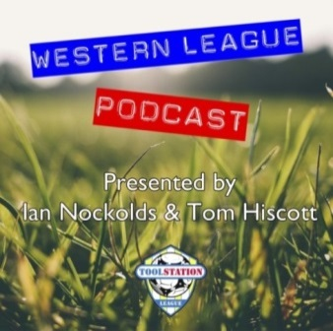

Be sure to check out the latest podcast, where Ian, Tom & guests recap all the latest news and results from around the Western League. To follow along all season, each broadcast will be available at the following link: http://www.toolstationleague.com/podcasts.php

Upcoming Fixtures
Monday 27th January 2020
First Division
Calne Town vs Welton Rovers 19:45KO
Tuesday 28th January 2020
Premier Division
Bridport vs Wellington 19:45KO
Buckland Athletic vs Odd Down 19:30KO
Chipping Sodbury Town vs Cadbury Heath 19:30KO
Keynsham Town vs Shepton Mallet 19:45KO
Street vs Clevedon Town 19:30KO
First Division
Cheddar vs Lebeq United 19:45KO
GFA Challenge Trophy – Third Round
Bristol Telephones vs Gala Wilton 19:45KO
Shortwood United vs Roman Glass St George 19:30KO
Wednesday 29th January 2020
First Division
Hengrove Athletic vs Wincanton Town 19:30KO
Somerset FA Premier Cup – Second Round
Radstock Town vs Yeovil Town 19:45KO
Devon FA St Lukes Bowl – Quarter Final
Plymouth Parkway vs Plymouth Argyle 19:30KO
Tavistock vs Torquay 19:30KO
Les Phillips Cup – Second Round
Bradford Town vs Bitton 19:30KO
Friday 31st January 2020
Premier Division
Bridgwater Town vs Clevedon Town 19:45KO
Saturday 1st February 2020 (KICK OFF AT 3.00PM UNLESS NOTED)
Premier Division
Bradford Town vs Chipping Sodbury Town
Buckland Athletic vs Bitton
Cadbury Heath vs Westbury United
Cribbs vs Keynsham Town
Odd Down vs Hallen
Plymouth Parkway vs Wellington
Roman Glass St George vs Exmouth Town
Tavistock vs Shepton Mallet
First Division
Almondsbury vs Ashton & Backwell United
Bishop Sutton vs Portishead Town
Bishops Lydeard vs Corsham Town
Bristol Telephones vs Sherborne Town
Calne Town vs Lebeq United
Cheddar vs Radstock Town
Hengrove Athletic vs Oldland Abbotonians
Warminster Town vs Wells City
Wincanton Town vs Longwell Green Sports
League Tables
Premier Division
 |  | P | W | D | L | F | A | GD | PTS
1 | Bradford Town | 20 | 17 | 1 | 2 | 63 | 19 | 44 | 52
2 | Plymouth Parkway | 19 | 16 | 1 | 2 | 70 | 19 | 51 | 49
3 | Exmouth Town | 19 | 15 | 2 | 2 | 47 | 14 | 33 | 47
4 | Shepton Mallet | 22 | 14 | 3 | 5 | 57 | 28 | 29 | 45
5 | Hallen | 22 | 14 | 3 | 5 | 48 | 35 | 13 | 45
6 | Tavistock | 19 | 14 | 2 | 3 | 50 | 23 | 27 | 44
7 | Bridgwater Town | 23 | 12 | 5 | 6 | 57 | 32 | 25 | 41
8 | Clevedon Town | 24 | 12 | 3 | 9 | 50 | 47 | 3 | 39
9 | Bitton | 20 | 12 | 1 | 7 | 51 | 31 | 20 | 37
10 | Street | 26 | 10 | 4 | 12 | 54 | 60 | -6 | 34
11 | Westbury United | 24 | 9 | 3 | 12 | 41 | 36 | 5 | 30
12 | Buckland Athletic | 19 | 9 | 2 | 8 | 35 | 36 | -1 | 29
13 | Brislington | 23 | 8 | 4 | 11 | 33 | 55 | -22 | 28
14 | Keynsham Town | 23 | 8 | 3 | 12 | 42 | 51 | -9 | 27
15 | Cadbury Heath | 25 | 6 | 7 | 12 | 30 | 57 | -27 | 25
16 | Roman Glass St George | 21 | 7 | 3 | 11 | 47 | 33 | 14 | 24
17 | Cribbs | 22 | 7 | 2 | 13 | 33 | 55 | -22 | 23
18 | Bridport | 24 | 5 | 1 | 18 | 33 | 78 | -45 | 16
19 | Chipping Sodbury Town | 24 | 5 | 1 | 18 | 28 | 76 | -48 | 16
20 | Wellington | 24 | 3 | 2 | 19 | 22 | 62 | -40 | 11
21 | Odd Down | 23 | 3 | 1 | 19 | 20 | 64 | -44 | 10

First Division
 |  | P | W | D | L | F | A | GD | PTS
1 | Calne Town | 20 | 14 | 2 | 4 | 35 | 13 | 22 | 44
2 | Longwell Green Sports | 22 | 13 | 3 | 6 | 53 | 35 | 18 | 42
3 | Wells City | 21 | 12 | 5 | 4 | 54 | 24 | 30 | 41
4 | Sherborne Town | 21 | 13 | 2 | 6 | 48 | 31 | 17 | 41
5 | Ashton & Backwell United | 21 | 11 | 6 | 4 | 35 | 35 | 0 | 39
6 | Corsham Town | 22 | 11 | 3 | 8 | 36 | 43 | -7 | 36
7 | Radstock Town | 17 | 11 | 1 | 5 | 44 | 26 | 18 | 34
8 | Wincanton Town | 17 | 10 | 2 | 5 | 35 | 34 | 1 | 32
9 | Cheddar | 20 | 9 | 4 | 7 | 34 | 32 | 2 | 31
10 | Bishops Lydeard | 19 | 9 | 3 | 7 | 46 | 32 | 14 | 30
11 | Oldland Abbotonians | 19 | 8 | 5 | 6 | 23 | 29 | -6 | 29
12 | Lebeq United | 21 | 9 | 0 | 12 | 45 | 50 | -5 | 27
13 | Warminster Town | 21 | 8 | 1 | 12 | 37 | 32 | 5 | 25
14 | Hengrove Athletic | 22 | 7 | 4 | 11 | 15 | 43 | -28 | 25
15 | Portishead Town | 21 | 6 | 4 | 11 | 38 | 38 | 0 | 22
16 | Almondsbury | 19 | 6 | 4 | 9 | 29 | 33 | -4 | 22
17 | Welton Rovers | 22 | 6 | 4 | 12 | 32 | 47 | -15 | 15
18 | Devizes Town | 21 | 3 | 6 | 12 | 32 | 47 | -15 | 15
19 | Bishop Sutton | 20 | 3 | 3 | 14 | 23 | 44 | -21 | 12
20 | Bristol Telephones | 20 | 2 | 2 | 16 | 28 | 55 | -27 | 8

